Mastering Engagement with Dynamic Difficulty Adjustment
Bryan Ang Wei Ze, Ng Yao Zhen Eugene, and Jericho Lorenz Villegas Quimson

1 Introduction
Every game developer faces a fundamental, perennial challenge: how to set the right difficulty. A game that is too easy quickly becomes boring, while one that is too hard causes frustration; both outcomes lead to the same undesirable result – player churn (Alexander et al., 2013; Andrade et al., 2006). The traditional solution has been to offer a static menu of choices: Easy, Normal, Hard. This approach, however, is deeply flawed. It forces players to predict their own skill in a game they have never played, creating a one-size-fits-all solution for a player base that is anything but uniform (Alexander et al., 2013). This content-centric model, where the player must adapt to a fixed challenge, is increasingly giving way to a more intelligent, responsive paradigm.

This new paradigm is built around Dynamic Difficulty Adjustment (DDA), a process by which a game’s AI automatically and intelligently modifies its challenge in real-time to match a player's skill level (Zohaib, 2018; Sepulveda et al., 2019). The goal is not simply to make the game easier or harder, but to keep players continuously challenged without feeling overwhelmed or bored, thereby maintaining a state of deep immersion and enjoyment known as "flow" (Hunicke, 2005; Hergenrather, 2020). This represents a fundamental shift in design philosophy from being content-centric to player-centric; the game itself adapts to the unique capabilities of each individual player. This is not merely a quality-of-life feature but a strategic tool with a clear economic imperative. By preventing the frustration and boredom that cause players to abandon a game, sophisticated DDA systems can directly address player churn, measurably improving player retention and, consequently, a game's commercial viability (Zaman & Toups, 2018; Hunicke, 2005).

This article serves as a practical guide for developers looking to harness the power of DDA. We will first explore the psychological theory of Flow that underpins DDA's effectiveness. We will then delve into the technical architectures for building these systems, from simple heuristics to advanced machine learning models. Finally, we will analyze the transformative impact of DDA on player retention, its role in widening audience accessibility, and its crucial application in balancing modern cooperative games.

2 The Psychology of Challenge – Engineering the "Flow" State
To effectively implement DDA, one must first understand the psychological state it aims to create. The core concept is "flow," a term coined by psychologist Mihaly Csikszentmihalyi to describe a state of optimal experience where a person is fully immersed in an activity (Csikszentmihalyi, 2009; Zohaib, 2018). During flow, focus becomes so intense that the sense of self, worldly concerns, and even time itself seem to dissipate. It is the feeling of being "in the zone," and it is intrinsically rewarding, making the activity highly enjoyable and motivating (Csikszentmihalyi, 2009; Alexander et al., 2013).
Csikszentmihalyi's research identified that flow occurs within a specific set of conditions, most critically when there is a perceived balance between the challenge of a task and the skill of the person performing it (Andrade et al., 2006). This relationship can be visualized as the "flow channel," as shown in Figure 1. If the challenge level significantly exceeds a person's skill, it induces anxiety and frustration. Conversely, if a person's skill far outweighs the challenge, it leads to boredom and apathy (Csikszentmihalyi, 2009). The flow state exists in the narrow, dynamic channel between these two negative states.
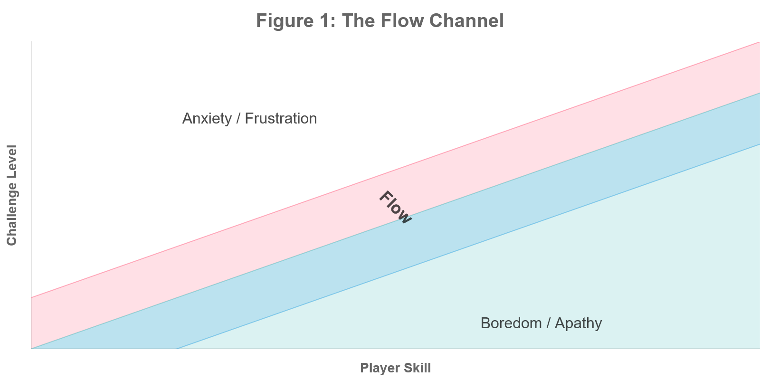
Figure 1: The flow channel illustrates the relationship between challenge and skill required to achieve an optimal psychological state.
Video games, by their very nature, are powerful engines for generating flow. They provide the necessary conditions: clear goals such as defeating the boss, solving the puzzle, etc.with immediate and unambiguous feedback such as health bars, score counters and visual effects (VFX) and a direct sense of control over one's actions (Alexander et al., 2013). However, maintaining this state is difficult because a player's skill is not static; it grows with experience. A challenge that was once engaging will eventually become trivial. This is where DDA becomes essential, as a well-designed DDA system acts as an algorithmic regulator, constantly monitoring the player's performance to keep them within their personal "Goldilocks zone", which refers to the sweet spot where the challenge is just right for the player (Alexander et al., 2013).

3 Player Modeling and DDA Architectures
The effectiveness of any DDA system hinges on two core components: a player model that accurately assesses skill and an architectural framework that uses that model to make intelligent adjustments. Moving from the "why" to the "how," this section details the practical steps and technical approaches for constructing a robust DDA system.

3.1 Comprehensive Player Modeling
The foundation of a sophisticated DDA system is a player model that looks beyond simplistic metrics like deaths or kill/death ratios. While easy to track, these metrics provide an incomplete picture of player competence. A player might die frequently not because of poor combat skill, but because they are experimenting with a novel strategy or are inefficient at managing resources. A truly player-centric DDA requires a more holistic profile built from a wider range of in-game behaviors (Hunicke, 2005).
A comprehensive player model should analyze multiple facets of gameplay to infer a player's true skill and playstyle. This includes tracking not just the outcome of actions, but the process behind them. As outlined in Table 1 below, by monitoring nuanced behaviors like resource management, tactical positioning, objective efficiency, and exploration patterns, a developer can build a much richer understanding of the player and tailor the DDA response accordingly (Hunicke, 2005). For example, a system that only tracks damage taken might incorrectly lower the difficulty for a skilled player who is intentionally drawing fire to protect their co-op partner. A more advanced model, however, would recognize this as effective tactical positioning and maintain or even increase the challenge.

Table 1 : Advanced player skill metrics provide a more nuanced basis for DDA responses than simple success/fail states.

Player Metric | Inferred Skill/State | Example DDA Response
Resource Management (e.g ammo efficiency, consumable usage rate) | High: Strategic, Thrifty  Low: Panicked, Wasteful | High Skill: Decrease ammo/health drops.  Low Skill: Increase ammo/health drops.
Tactical Positioning (e.g time spent in cover, distance from enemies) | High: Cautious, Tactical  Low: Aggressive, Reckless | High Skill: Increase enemy flanking behavior, use of grenades.  Low Skill: Reduce enemy accuracy, decrease aggression.
Objective Efficiency (e.g time to complete primary goals) | High: Focused, Efficient  Low: Distracted, Struggling | High Skill: Introduce more complex secondary objectives, add time pressure.  Low Skill: Provide subtle navigational hints, reduce enemy patrols near objectives.
Exploration Patterns (e.g percentage of map uncovered) | High: Thorough, Curious  Low: Linear, Rushing | High Skill: Place high-value rewards in hard-to-reach areas.  Low Skill: Increase resource visibility on the main path.

3.2 Architectural Approaches
Once a player model is established, the next step is to choose an architecture to act on that data. DDA systems exist on a spectrum of complexity, with each approach offering a different trade-off between implementation cost and adaptive power.

3.2.1 Heuristic-Based DDA

The most straightforward and common architecture is the heuristic-based system. This approach uses a set of predefined, human-authored rules to link player performance metrics to game parameter adjustments (Zohaib, 2018; Zaman & Toups, 2018). These are typically simple if-then statements that trigger when a player's performance crosses a certain threshold. For instance, in a horde shooter, if the system detects that the player's health has dropped below 25% multiple times in a short window, a rule might trigger to increase the drop rate of health packs. While reactive, this method is computationally inexpensive and relatively easy for designers to implement, tune, and understand, as demonstrated in the Code Section (5).

3.2.2 Probabilistic and Data-Driven DDA
A more advanced approach moves from reactive rules to predictive models. Instead of simply responding to past events, these systems use historical player data to predict future outcomes and adjust the game to optimize for a specific goal, such as maximizing player engagement. A notable example of this is a system developed at Electronic Arts, which models a player's progression through a level-based game as a probabilistic graph (Zaman & Toups, 2018).
In this model, each state is defined by the player's current level and their number of attempts. The system calculates the probabilities of three possible transitions from any state: winning and advancing, losing and retrying, or churning (quitting the game). By analyzing vast amounts of historical player data, the system can estimate the churn rate associated with winning or losing at any given state. The DDA then becomes an optimization problem: what win rate at each state will maximize the player's total expected playtime before they either finish the game or churn? This data-driven framework allows the system to make proactive adjustments, fine-tuning difficulty not just to match skill, but to actively guide the player along a path of maximum engagement. This system was shown to improve player engagement by up to 9% in live games (Zaman & Toups, 2018).

3.2.2 Probabilistic and Data-Driven DDA

The cutting edge of DDA involves leveraging machine learning (ML) to create highly adaptive and personalized experiences. These systems can build complex, non-linear models of player behavior that are far more nuanced than simple heuristics.

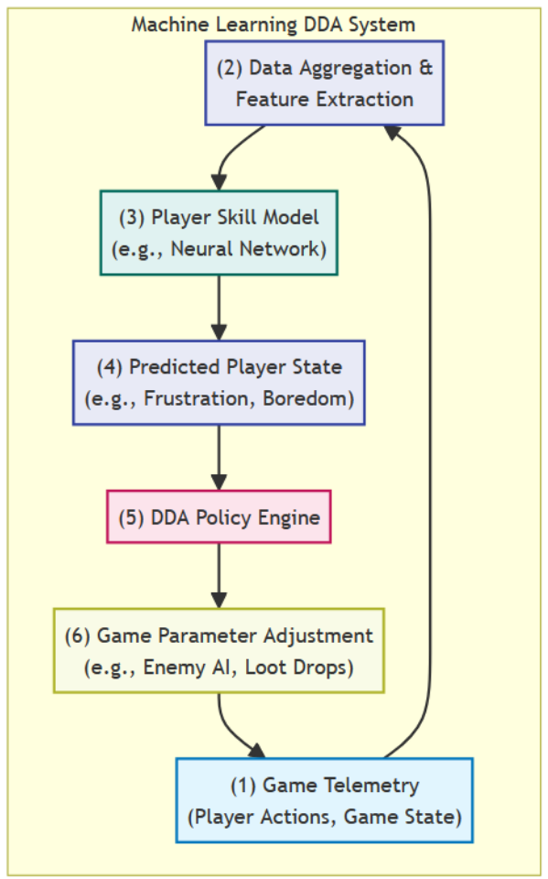
Figure 2: A machine learning DDA system operates as a continuous feedback loop, refining game parameters based on a predictive model of the player's state.

ML-based approaches can take several forms. Reinforcement Learning (RL) can be used to train an AI opponent that learns to match the player's skill level over time (Zohaib, 2018). One novel technique involves a two-agent system: an "imitation agent" learns to mimic the player's specific playstyle, and a second "RL agent" is then trained to be the perfect opponent for that imitation agent (Fuchs et al., 2024). When the player faces this RL agent, they are essentially competing against an AI that has been custom-built to challenge their unique strategies. Other research explores meta-learning, where a model is trained on data from thousands of players not to master the game, but to become an expert at learning how a new player plays. This allows the DDA system to adapt incredibly quickly to a new user with only a small amount of gameplay data, creating a personalized experience almost instantly (Moon & Seo, 2020).
These advanced player models can be seen as a form of procedural persona generation. Rather than designing for static, predefined player types like "The Explorer" or "The Achiever," the system creates a dynamic, data-driven persona for each individual in real-time. This opens the door to a more sophisticated form of DDA that adapts not just the difficulty, but the very type of challenge presented, tailoring the gameplay to match a player's inferred motivations and playstyle.

4 The Broader Impact: Retention, Accessibility, and Cooperation
When implemented effectively, DDA transcends being a mere background system and becomes a powerful tool that can fundamentally improve a game's design, expand its audience, and enhance its commercial success. Its impact is felt across three key areas: retaining the existing player base, making the game accessible to a wider one, and solving the complex balancing challenges of cooperative play.

4.1 Boosting Player Retention

The most direct commercial benefit of DDA is its proven ability to increase player retention. A primary reason players abandon a game is due to frustration from insurmountable difficulty spikes or boredom from a lack of challenge (Andrade et al., 2006; Hergenrather, 2020). DDA is designed to smooth out these extremes, keeping players engaged in the rewarding state of flow. As previously mentioned, a data-driven DDA framework implemented by Electronic Arts demonstrated a tangible impact, improving player engagement by up to 9% with a neutral effect on monetization (Zaman & Toups, 2018).
Recent research has formalized this goal with the concept of Engagement-Oriented Dynamic Difficulty Adjustment (EDDA). Unlike traditional systems that react primarily to performance, EDDA models directly incorporate a player's churn trend as a key input (Zaman & Toups, 2018). By monitoring gameplay time and identifying patterns that historically precede a player quitting, the system can intervene proactively to adjust the difficulty and prevent churn. This approach treats retention not as a happy byproduct of good design, but as the central optimization objective of the DDA system itself.

4.2 DDA for Accessibility

Beyond retaining current players, DDA is a powerful tool for making games accessible to a much broader audience (Zohaib, 2018). Many potential players are deterred by games with a reputation for high difficulty, as they may lack the time, experience, or physical ability to overcome a steep, fixed challenge. DDA serves as an elegant, built-in accessibility feature that can tailor the experience to any skill level, from a complete novice to a seasoned veteran (Sepulveda et al., 2019; Zohaib, 2018).
This can be particularly transformative for notoriously difficult genres. For example, titles from FromSoftware like Elden Ring or Sekiro: Shadows Die Twice are celebrated for their challenge but can be unapproachable for many. An optional, well-implemented DDA system could allow a wider range of players to experience these rich worlds and celebrated designs without compromising the core, unforgiving experience that dedicated fans cherish (Hunicke, 2005). The system could subtly adjust enemy aggression, timing windows for parries, or resource availability, making the game more manageable for those who need it while remaining invisible to those who don't. This widens the commercial funnel, allowing more players to engage with and purchase the game, without alienating the core audience.

4.3 DDA in Cooperative Games

Perhaps the most complex and compelling application of DDA is in cooperative multiplayer games. Balancing a game for a single player is challenging enough; balancing it for a team of two, three, or four players with widely varying skill levels is exponentially more difficult (Zohaib, 2018). If the difficulty is tuned to the strongest player, novices will be frustrated and left behind. If it's tuned to the weakest, experts will be bored and unengaged. DDA provides a solution to this classic co-op design problem.
The seminal case study in this domain is the AI Director from Valve's Left 4 Dead. The Director is much more than a simple difficulty slider; it is a sophisticated system designed to manage the pacing and dramatic tension of the cooperative experience (Booth, 2009). It operates as a finite state machine, constantly transitioning the game's intensity through three key states: a Build-up phase where tension gradually mounts, a Peak phase where the team faces an overwhelming horde, and a Cooldown phase that provides a moment of respite to heal and regroup (Booth, 2009).

*Arrows indicate the intended transitions between states.
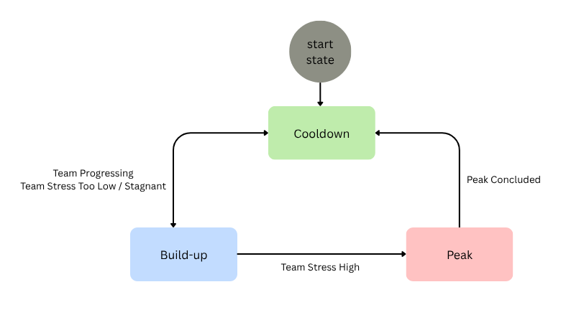
Figure 3: The AI Director in Left 4 Dead functions as a state machine to control the dramatic pacing of gameplay.

Crucially, the AI Director's decisions are based on the team's collective state, not just individual performance. It monitors a "stress" level for each player – a metric based on factors like damage taken and proximity to enemies, and uses the aggregate stress of the group to guide its pacing decisions (Booth, 2009). This system also serves to enforce cooperative play. If a single player sprints ahead of the group, the Director is more likely to target them with special infected, punishing this "lone wolf" behavior and reinforcing the need for teamwork. By procedurally spawning enemies, weapons, and health kits based on the team's location, performance, and current stress levels, the AI Director ensures that no two playthroughs are the same, creating a highly replayable and consistently thrilling cooperative challenge (Booth, 2009). The Director's success demonstrates that in a cooperative context, the goal of DDA shifts from balancing for individuals to creating conditions that encourage and reward cohesive teamwork.

5 Code (Horde Shooter Demo)
This section presents the core algorithms from our Unity-based DDA implementation. The system consists of three components: Performance tracking monitors player metrics, difficulty adjustment calculates optimal challenge levels with smoothing to prevent jarring transitions, and content scaling applies these values to game elements like enemy spawning rates.

5.1 Core Performance Calculation
The performance tracking algorithm employs a weighted combination approach as implemented in the PlayerPerformanceTracker class:

private float CalculatePerformanceScore(PlayerMetrics metrics)
{
if (metrics.totalEnemiesEncountered == 0) return 0.5f;
float killRatio = metrics.enemiesKilled / metrics.totalEnemiesEncountered;
float healthRatio = metrics.currentHealth / metrics.maxHealth;
float accuracyScore = metrics.accuracy;
float deathPenaltyFactor = 1f;
if (deathCount > 0 && metrics.survivalTime > 0)
{
float deathsPerMinute = (deathCount / (metrics.survivalTime / 60f));
deathPenaltyFactor = Mathf.Clamp01(1f - (deathsPerMinute * 0.1f));
}
float performanceScore = (killRatio * 0.4f) + (healthRatio * 0.3f) + (accuracyScore * 0.3f);
performanceScore *= deathPenaltyFactor;
return Mathf.Clamp01(performanceScore);
}

5.2 Difficulty Adjustment Algorithm
The DDA system implements gradual adjustment with built-in limits to prevent dramatic difficulty swings:

public float CalculateNewDifficulty(PlayerMetrics metrics)
{
float performanceScore = CalculatePerformanceScore(metrics);
float timePressure = CalculateTimePressure(metrics);
float overallPerformance = (performanceScore * performanceWeight) + (timePressure * timeWeight);

float performanceDelta = overallPerformance - targetWinRate;
float rawDifficultyChange = performanceDelta * adaptationRate;
float cappedDifficultyChange = Mathf.Clamp(rawDifficultyChange,
-maxDifficultyChangePerUpdate, maxDifficultyChangePerUpdate);
float smoothedChange = cappedDifficultyChange * difficultyChangeSmoothing;

currentDifficulty = Mathf.Clamp(currentDifficulty + smoothedChange, minDifficulty, maxDifficulty);
return currentDifficulty;
}

5.3 Enemy Spawning Algorithm
The EnemySpawner implements dynamic population control:

float difficultyFactor = (currentDifficulty - 1f) / 9f;
float spawnRate = baseSpawnRate * (1f - (difficultyFactor * spawnRateReduction));
int enemyCount = Mathf.RoundToInt(baseEnemyCount + (difficultyFactor * enemyCountIncrease));
spawnRate = Mathf.Max(0.8f, spawnRate);
enemyCount = Mathf.Max(1, enemyCount);

6 Conclusion

Dynamic Difficulty Adjustment, when grounded in the psychological principles of flow, represents a paradigm shift toward truly player-centric game design. By moving beyond rigid, one-size-fits-all difficulty settings, DDA empowers developers to craft personalized experiences that can significantly enhance player engagement, widen audience accessibility, and solve the intricate balancing challenges of cooperative play. From simple heuristic rules to complex machine learning models, the available architectures offer a spectrum of solutions that can be tailored to the scope and ambition of any project.
However, the power of DDA comes with a critical caveat: its implementation requires the subtle touch of an artist. The most effective DDA is an invisible hand, guiding the player's experience so seamlessly that the adjustments feel natural and emergent rather than artificial and manipulative (Hergenrather, 2020; Andrade et al., 2006). An obvious or clumsy system can shatter a player's sense of agency and accomplishment, making them feel patronized when the game becomes easier or cheated when it becomes harder (Andrade et al., 2006; Zohaib, 2018). This "DDA uncanny valley," where a poorly implemented system feels worse than no system at all, is a significant pitfall that developers must strive to avoid.
Furthermore, as these systems become more data-driven and opaque, developers must be mindful of the ethical responsibilities involved. Algorithmic systems can perpetuate biases present in their training data (Fuchs et al., 2024; Moon & Seo, 2020), and the use of DDA to influence player behavior, particularly when linked to monetization, treads a fine line between enhancing engagement and creating manipulative feedback loops (Zaman & Toups, 2018). Transparency and a player-first design ethos are paramount.
Ultimately, the future of DDA lies in a deeper form of personalization. Emerging research in areas like meta-learning and imitation learning points toward systems that do not just adapt to a player's skill, but learn their unique style, creating bespoke challenges and opponents (Fuchs et al., 2024; Moon & Seo, 2020). This evolution from adjustment to true personalization promises a future where games can offer every player a unique, memorable, and perfectly tailored challenge. DDA should not be seen as a crutch for weak design, but as a sophisticated AI tool for achieving one of game development's oldest and most important goals: to create the perfect level of fun for everyone.

7 References

Alexander, J. T., Sear, J., & Oikonomou, A. (2013). An investigation of the effects of game difficulty on player enjoyment. Journal of Gaming & Virtual Worlds, 5(1), 59–74.

Andrade, G., Ramalho, G., Santana, H., & Corruble, V. (2006). Challenge-sensitive action selection: an application for game balancing. In Proceedings of the 2006 ACM SIGCHI international conference on Advances in computer entertainment technology (p. 21). ACM.

Booth, M. (2009). Replayable cooperative game design: Left 4 Dead. Game Developers Conference (GDC) 2009. Valve.

Csikszentmihalyi, M. (2009). Flow: The psychology of optimal experience. Harper & Row.

Fuchs, R., Gieseke, R., & Dockhorn, A. (2024). Personalized Dynamic Difficulty Adjustment -- Imitation Learning Meets Reinforcement Learning. arXiv preprint arXiv:2408.06818.

Hergenrather, B. (2020). Dynamic Difficulty: A Player Perspective. WRIT: Journal of First-Year Writing, 3(1), 4.

Hunicke, R. (2005). The case for dynamic difficulty adjustment in games. In Proceedings of the 2005 ACM SIGCHI International Conference on Advances in computer entertainment technology (pp. 429-433).

Moon, H. S., & Seo, J. (2020). Dynamic Difficulty Adjustment via Fast User Adaptation. arXiv preprint arXiv:2006.15545.

Sepulveda, G. K., Besoain, F., & Barriga, N. A. (2019). Exploring Dynamic Difficulty Adjustment in Videogames. In 2019 CHILEAN Conference on Electrical, Electronics Engineering, Information and Communication Technologies (CHILECON) (pp. 1-6). IEEE.

Zaman, K. A., & Toups, Z. O. (2018). Dynamic Difficulty Adjustment for Maximized Engagement in Digital Games. In Proceedings of the 23rd International Conference on Intelligent User Interfaces (pp. 235-246).

Zohaib, M. (2018). Dynamic difficulty adjustment (DDA) in computer games: A review. Advances in Human-Computer Interaction, 2018.

